Building a Campus Study Assistant with Amazon Bedrock (Part 1: Model Setup & Model Connectivity)
How I automated technical coursework analysis using Python and AWS Bedrock.
As an IT student balancing dense course syllabi and technical material, I wanted to automate how I extract key concepts from study materials. Instead of reading through 40-page PDFs manually, I decided to build a customized document analyzer using Amazon Bedrock. In this first part, I will walk you through how I connected Python to Bedrock via Boto3 to lay the foundation for my campus study assistant.

Step 1: Request & Verify Access in AWS Bedrock Console.
- Sign in to Management Console and go to Amazon Bedrock.
- In the Model Catalog on the left menu, locate and verify access for Anthropic Claude 4.5 Haiku.
- Why Claude Haiku? It is optimized for ultra-low latency and low cost. It provides near-instant responses for extraction and summarization tasks, making it most budget-friendly choice for building and testing student project workflows.
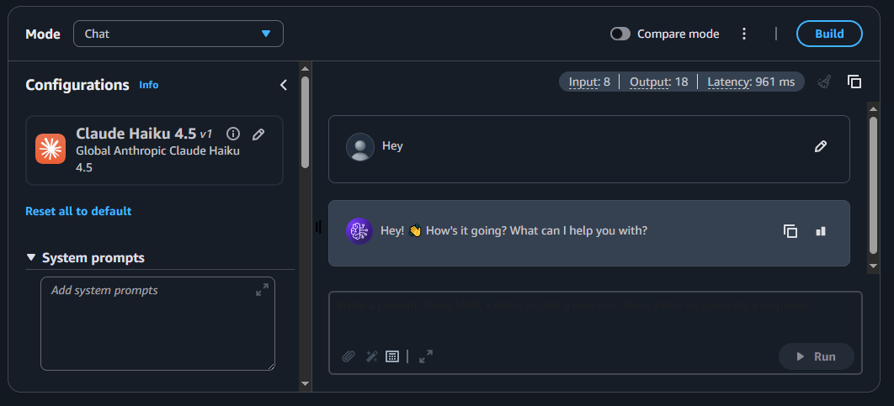

Step 2: Set Up Computer Environment
- In VS Code we made a folder (campus-doc- analyzer) and installed boto3 (the official AWS SDK) and awscli (to provide command line tools that interact with the AWS account and help save security keys safely on the computer)
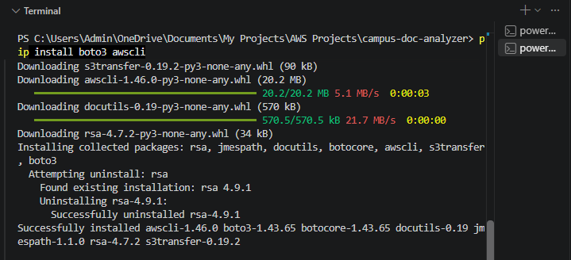
- Run AWS Configure in the terminal and input the access key, secret access key, Region Name, Output Format: json. (I got the access keys from the IAM user security credentials page in the console). This is for security and authentication and region routing.

Note: Never commit your .aws/credentials file or raw Access Keys to GitHub! Using aws configure stores them locally outside your code repository to keep your account safe.

Step 3: Write a python script:
- Code used is shown below:
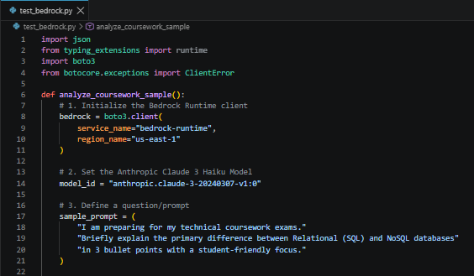

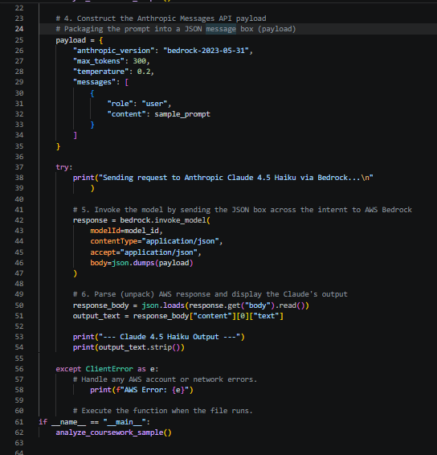

Code summary:
- Python uses boto3 to locate my saved AWS credentials
- It sends the question/prompt to Claude 4.5 Haiku hosted on AWS Bedrock.
- AWS processes the request and sends back a JSON response
- Python unwraps the JSON and displays the 3 bullet points in my terminal.

Step 4: Run the script in terminal
- Run the code using this: Python test_bedrock.py.
This should be the output:
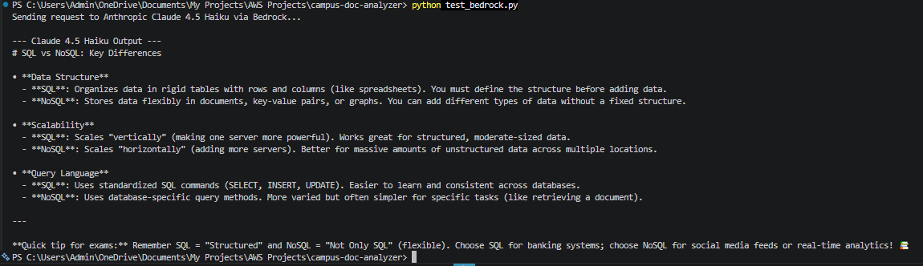
- Executing our script successfully invoked Anthropic Claude via Amazon Bedrock. The model processed our prompt and returned a clear, structured response straight to the terminal output. With our API connection verified, we now have a solid foundation to build out more complex features for our document analyzer project.

Challenges faced and how I resolved them:

Challenge | Solution
- Indentation of this line of code:  if __name__ == "__main__":  analyze_coursework_sample() | Shifted the line to the far left (unindented) so Python executes the function when running the file.
- When running python test_bedrock.py, AWS returned a ResourceNotFoundException: Access denied error, stating that the default Claude model ID was marked as legacy(outdated) by the provider. (the claude 3) | Updated the model id in the Python script from the legacy ID to an active global inference profile ID (model_id = "us.anthropic.claude-haiku-4-5-20251001-v1:0"), which properly routes the API request through AWS Bedrock.  NB: I found the model.id in the Amazon Bedrock console in the Model Catalog specifically Claude Haiku.

Relevant Resources:
- AWS Bedrock Console: https://us-east-1.console.aws.amazon.com/bedrock/
- Amazon Bedrock Pricing: https://aws.amazon.com/bedrock/pricing/

In Part 2, we’ll build on this foundation by loading real coursework PDFs, processing large document contexts, and setting up intelligent Q&A and summarization.

